User Manual

Data Visualisation of Crash Statistics Victoria

**Student Names**   
   
**Samaar Bajwa s5254805**   
**Christopher Burrell s5237645**   
**Gauruv Grover s5320837**   
 

# Description:

This document is used to help provide a description of the actions that must be performed by the users in order to operate the system.

# History:

**Version Description Author Date**

0.01 Initial Draft Samaar Bajwa 08/10/23

0.02 Second Draft Chris Burrell 08/10/23

Contents

Description: 2

History: 2

1.0 Overview 4

1.1 Introduction 4

1.2 Installation and Setup 4

1.3 User Interface Overview 5

1.4 Home Page 5

Overview: 6

**Navigation Menu:** 6

 6

Overview: 8

Map Tool 10

Overview: 10

Picture 1. Home Page screen. 6

# 1.0 Overview

## 1.1 Introduction

The VSADS (Vehicle Crash Statistics and Analysis) Visualisation Tool is a user-friendly application designed to help users analyse and visualize vehicle crash data. This user manual provides an overview of the tool's features and functionality.

## 1.2 Installation and Setup

The current use of the VSADS Visualisation Tool requires the user to install the required dependencies and set up the application.

**Requirements:**

* Python
* wxPython
* pandas
* SQLite database (crash_data.db)
* Crash data CSV file (Crash Statistics Victoria.csv)
* State graphic file (state_vic_graphic.jpg)

##### 1.2.1 Installation Steps

The following steps must be taken to allow the VSADS Visualisation tool to be run in its current configuration.   
  
1. Install Python: If you haven't already, download and install Python from the official Python website (<https://www.python.org/>) .

2. Install Dependencies:

* Install wxPython using pip:
  + pip install wxpython
* Install pandas using pip
  + pip install pandas

3. Create SQLite Database:

* Create a SQLite database named crash_data.db.
* Define the database schema as specified in the code.

4. Prepare Data Files:

* Place the CSV crash data file (Crash Statistics Victoria.csv) in the same directory as the application.
* Place the state graphic file (state_vic_graphic.jpg), accident types plot file (accident_types.png), and accident locations plot file (accident_locations.png) in the appropriate locations.

## 1.3 User Interface Overview

The VSADS Visualisation Tool has a user-friendly interface with three main pages accessible through tabs: "Home," "Accident Information," and "Map." Here's an overview of the user interface elements:

* Home Page: Provides basic information about the application and accident data.
* Accident Information Page: Allows users to explore accident data through different tabs:
  + Type of Accident: Displays a plot of accident types.
  + Day of the Week: Displays a plot of the days of the week that accidents occur.
  + Hour of the Day: Displays a plot of breakdown for which accidents occur.
* Map Page: Displays a map with accident locations, geo-located to the longitude and latitude.

## 1.4 Home Page

##### 1.4.1 Overview

The "Home" page serves as an introduction to the application. It provides a clean aesthetic with a title, and a State of Victoria graphic logo. A brief overview of the available functionality is presented to the user through tabs, that the users can navigate to other pages with.

Picture 1. Home Page screen.

## 1.5 Accident Information Page

##### 1.5.1 Overview

The "Accident Information" page is where users can explore accident data in more detail.   
A Search bar is presented to the lest of the screen with various keywords relating to the accident types. A clear button is available for the user to clear current accident type selections, and a Generate Report button is available, for when the user wants to see the data.   
  
The user is also provided with a Date Picker field. The default of these fields is set to the maximum and minimum values for the data range. Clicking on the Calander icon to the right of the date provides a calendar representation that the user can select from, or additionally the user can select on the date itself, and manually enter the date in a day/month/year format.

Additionally in the Accident Information screen (*Picture 2*), the user can toggle between the outputs of the search after the Generate Report button is clicked. These tabs will be explained in further detail below, with their functionality and outputs explained.

Picture 2. Accident Information screen.

Picture 3. Calander Date Selection



Picture 4. Manual Date Entry.

1. Accident Types:

* **Description:** Select the type of accidents you wish to include in the graph.
* **How to Use:** Check the boxes corresponding to the desired accident types.

2. Date Select:

* **Description:** Choose a specific date or date range for which you want accident data.
* **How to Use:** Click on the date box and select a date from the calendar drop-down. If selecting a range, repeat this for both start and end dates.

3. Alcohol Related:

* **Description:** Filter the data based on whether the accident was alcohol-related.
* **How to Use**: Check the "Alcohol Related?" box to only include accidents where alcohol was a factor.

4. Type of Accident/Time of Day/Day of Week:

* **Description:** Specify if you wish to segment the data based on the type of accident or the time of day the accident occurred.
* **How to Use:** From the tabs, choose the desired type of data to be displayed.

5. Clear:

* **Description:** Reset all selection criteria to their default settings.
* **How to Use:** Click on the "Clear" button.

6. Generate Report:

* **Description:** Create a visual representation (graph) based on the selected criteria.
* **How to Use:** After selecting your desired criteria, click on the "Generate Report" button.

##### 

##### 1.5.2 Type of Accident

This tab displays a plot of the accidents in a Horizontal bar chart. The types of accidents for the selected period are displayed along the Y-Axis, with the frequency of occurrence along the X-Axis. A simple grid is also added to the chart to allow visual data comparison.

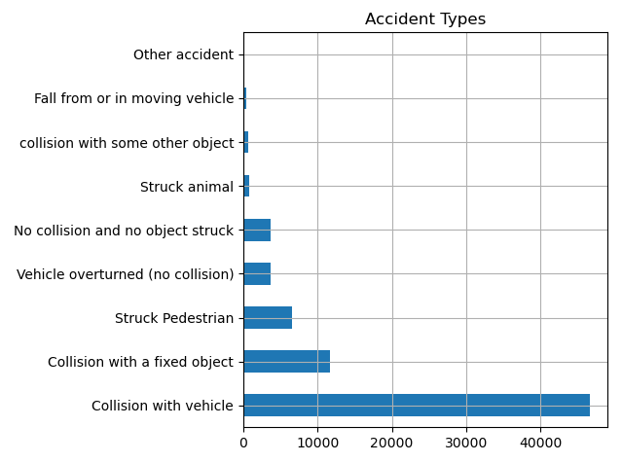

Picture 5. Accident Type Output.

1. Accident Types:

* **Description**: Select the type of accidents you wish to include in the graph.
* **How to Use**: Check the boxes corresponding to the desired accident types.

2. Date Select:

* **Description**: Choose a specific date or date range for which you want accident data.
* **How to Use**: Click on the date box and select a date from the calendar drop-down. If selecting a range, repeat this for both start and end dates.

3. Alcohol Related:

* **Description**: Filter the data based on whether the accident was alcohol-related.
* **How to Use**: Check the "Alcohol Related?" box to only include accidents where alcohol was a factor.

##### 1.5.3 Time of Day (To be Implemented)

This tab provides an insight into the accidents based on the time of day, within a 24hr time cycle, that the accident occurs. Graphs and data will be displayed here in future updates of the software, with the parameters the user selects being taken into consideration.

Time of Day:

* **Description**: Specify if you wish to segment the data based on the type of accident or the time of day the accident occurred.
* **How to Use**: From the drop-down menus, choose the desired type of accident or time of day.

##### 1.5.4 Day of the Week (To be Implemented)

This tab provides an insight into the day of the week that the accident occurs. Graphs and data will be displayed here in future updates of the software, with the parameters the user selects being taken into consideration.

Time of Day:

* **Description**: Specify if you wish to segment the data based on the type of accident or the time of day the accident occurred.
* **How to Use**: From the drop-down menus, choose the desired type of accident or time of day.

## 1.6 Map Page

##### 1.6.1 Overview

The "Map Page" is designed to offer a visual representation of accident locations in Victoria, Australia. Users can filter accident data based on specific criteria and view the spatial distribution of accidents on a map.

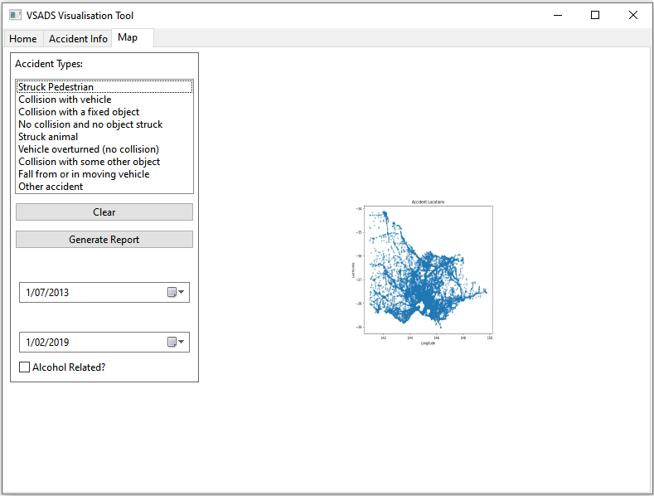

Picture 6. Map Screen

1. Accident Map:

* **Description**: A map highlighting accident locations in Victoria, Australia.
* **How to Use**:

2. Accident Types:

* **Description**: Select the type of accidents you wish to include in the graph.
* **How to Use**: Check the boxes corresponding to the desired accident types.

3. Date Select:

* **Description**: Choose a specific date or date range for which you want accident data.
* **How to Use**: Click on the date box and select a date from the calendar drop-down. If selecting a range, repeat this for both start and end dates.

4. Alcohol Related:

* **Description**: Filter the data based on whether the accident was alcohol-related.
* **How to Use**: Check the "Alcohol Related?" box to only include accidents where alcohol was a factor.

5. Clear:

* **Description**: Reset all selection criteria to their default settings.
* **How to Use**: Click on the "Clear" button.

6. Generate Report:

* **Description**: Create a visual representation (graph) based on the selected criteria.
* **How to Use**: After selecting your desired criteria, click on the "Generate Report" button.

## 2.0 Conclusion

The VSADS Visualisation Tool provides users with valuable insights into vehicle crash data. With its user-friendly interface and interactive features, users can explore, analyse, and generate reports based on accident data.

For additional support or inquiries, please contact the tool's authors: Chris Burrell and Gauruv Grover.